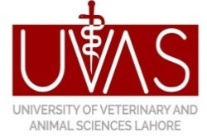
University of Veterinary & Animal Sciences, Lahore
(Office of the Dean, Faculty of Animal Production & Technology)

APPLICATION FOR BONAFIDE CERTIFICATE

Student’s Name: Father’s Name:

 |  |  |  |  | - |  |  |  |  |  |  |  | -

CNIC #:

Contact Number: |  | Cell Number

Name of Degree Program:

Registration #:

Session: | Morning | Evening

Duration of Degree Program | 02 Year | 04 Year

Year/Date of Admission |  | Degree Completion Date/Year

Why you Need bonafide:

Dated:
Student’s Signature

Recommended & Forwarded by

(Signature & Stamp (Head of Department) Approved by

Dean’s Signature

Office Use Only

Issued Vide # Dated Issued by

Received by

Student’s Signatures

Documents to be attached.

1. Copy of University I.D Card & CNIC
2. Result of Previous Semester

